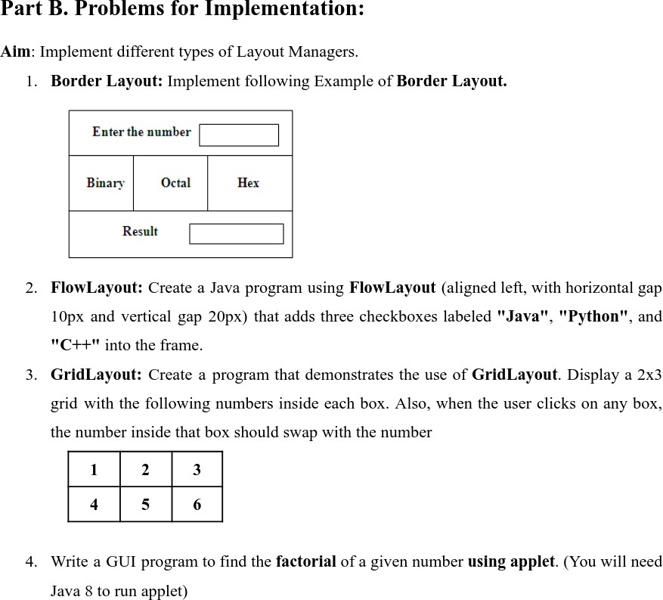

1->
import java.awt.*; import javax.swing.*;

public class BorderLayoutExample {
public static void main(String[] args) {
JFrame frame = new JFrame("Border Layout"); frame.setSize(300, 200);
frame.setLayout(new BorderLayout());

JPanel topPanel = new JPanel(); topPanel.add(new JLabel("Enter the number")); JTextField input = new JTextField(10); topPanel.add(input);
frame.add(topPanel, BorderLayout.NORTH);

JPanel centerPanel = new JPanel(new GridLayout(1, 3)); centerPanel.add(new JButton("Binary")); centerPanel.add(new JButton("Octal")); centerPanel.add(new JButton("Hex")); frame.add(centerPanel, BorderLayout.CENTER);

JPanel bottomPanel = new JPanel(); bottomPanel.add(new JLabel("Result")); bottomPanel.add(new JTextField(10)); frame.add(bottomPanel, BorderLayout.SOUTH);

frame.setDefaultCloseOperation(JFrame.EXIT_ON_CLOSE); frame.setVisible(true);
}
}

2->
import java.awt.*; import javax.swing.*;

public class FlowLayoutExample {
public static void main(String[] args) { JFrame frame = new JFrame("Flow Layout"); frame.setSize(300, 100);
frame.setLayout(new FlowLayout(FlowLayout.LEFT, 10, 20)); frame.add(new JCheckBox("Java"));
frame.add(new JCheckBox("Python")); frame.add(new JCheckBox("C++"));
frame.setDefaultCloseOperation(JFrame.EXIT_ON_CLOSE); frame.setVisible(true);
}
}

3->
import java.awt.*; import java.awt.event.*; import javax.swing.*;

public class GridLayoutExample {
public static void main(String[] args) { JFrame frame = new JFrame("Grid Layout"); frame.setSize(200, 200);
frame.setLayout(new GridLayout(2, 3)); JButton[] buttons = new JButton[6];

for (int i = 0; i < 6; i++) {
buttons[i] = new JButton(String.valueOf(i + 1)); frame.add(buttons[i]);
}
for (int i = 0; i < 6; i++) { int index = i;
buttons[i].addActionListener(e -> {
String temp = buttons[index].getText(); buttons[index].setText(buttons[0].getText()); buttons[0].setText(temp);
});
}
frame.setDefaultCloseOperation(JFrame.EXIT_ON_CLOSE); frame.setVisible(true);
}
}

4->
import java.awt.*; import java.awt.event.*; import java.applet.*;

public class FactorialApplet extends Applet implements ActionListener { TextField input, result;
Button calc;

public void init() {
input = new TextField(10); result = new TextField(10); calc = new Button("Calculate");
add(new Label("Enter number:")); add(input);
add(calc);
add(new Label("Factorial:")); add(result); calc.addActionListener(this);
}

public void actionPerformed(ActionEvent e) { int n = Integer.parseInt(input.getText());
int fact = 1;
for (int i = 2; i <= n; i++) fact *= i; result.setText(String.valueOf(fact));
}}

